 ELECTRONICS
COLLECTION EVENT

 Vintage Tech Recyclers
Residential
Electronics
ONLY

will be on site for Earth Day

When: Sunday, May 18, 2008
10:00 to 4:00

Where: DELLWOOD PARK
Lockport, IL

Directions: 1 Mile South of 159th (Rte 7/Renwick) on Archer Ave/ Rte 171, Left into park to Earth Day Event.
JOIN OUR FREE EARTH DAY EVENT ~ A FUN FILLED DAY OF SPEAKERS & ACTIVITIES FOR ALL AGES!
Recycle Shoes, Eyeglasses & Bikes
Live Wolf/Coyote & Reptile Presentations
(weather Permititng)

FREE ACCEPTABLE ITEMS
Cell Phones, Telephones, Computers, Monitors, Printers, Modems, External Disk Drives, CD Players, DVD Players, Digital Games, Stereo Equipment, Speakers, UPS’s, VCR’s, Toner/Ink Cartridges

TV’s up to 32” $15 - 32” & larger $25

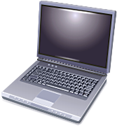
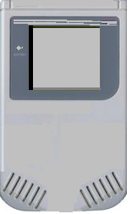

UNACCEPTABLE ITEMS
Appliances, Air Conditioners, Water Heaters, Refrigerators, Ovens, Garbage Disposals, Fire Extinguishers, Household Hazardous Waste, Regular Garbage or Business Electronic Items

Sponsored by:
Citizens Against Ruining the Environment – CARE 815-834-1611

carelockport@usa.com

